## **New Installation Server Setup Guide.**

This is the installation guide for facilities without existing KenyaEMR instances running.

**Prerequisites.**

1. **Ubuntu 16.04 LTS**
2. **Mysql server 5.6**
3. **Java 7**
4. **Apache TOMCAT 6**

**1. Install Oracle Java, MySQL and Apache Tomcat**

**Open terminal(Ctrl+Alt+T)**

1. **Install MySQL Server 5.6**

**Open terminal(Ctrl+Alt+T)**

a) Remove existing mysql-5.7 Default package is 5.7: if exists:

**sudo apt remove mysql-client mysql-server libmysqlclient-dev mysql-common**

**sudo apt-get purge mysql\***

**sudo apt-get autoremove**

**sudo apt-get autoclean**

remove mysql,mysql-files and mysql-keyring from /var/lib directory

**sudo rm mysql-files**

**sudo rm mysql-keyring**

b) Install Mysql-5.6 <Accurate>

**sudo add-apt-repository 'deb** [**http://archive.ubuntu.com/ubuntu**](http://archive.ubuntu.com/ubuntu) **trusty universe'**

**sudo apt-get update**

**sudo apt-get install mysql-server-5.6**

**It should bring a purple screen which will prompt password.**

**NB: Set a password for MySQL root account when prompted.**

c) Auto start MySQL

Execute the following command to force MySQL service to start automatically during system reboot.

**sudo update-rc.d mysql defaults**

1. **Jdk 1.7.0_18 Installation**

Download the jdk7 package from [google drive](https://drive.google.com/drive/folders/1XGV9AHleMbgKFudee9ezrvnixA5z-byx?usp=sharing), extract it on the folder you downloaded it to

**sudo mkdir -p /usr/local/java**

**sudo mv jdk1.7.0_80/ /usr/local/java/**

**cd /usr/local/jav**a

**ls**

#you should see jdk1.7.0_80

#Open */etc/profile* with sudo privileges to point to the Java path

**sudo nano /etc/profile**

#Add the Java Path at the end of the file

**JAVA_HOME=/usr/local/java/jdk1.7.0_80**

**JRE_HOME=/usr/local/java/jdk1.7.0_80**

**PATH=$PATH:$JRE_HOME/bin:$JAVA_HOME/bin**

**export JAVA_HOME**

**export JRE_HOME**

**export PATH**

#Then update the alternatives (Copy Line 1, 2 and 3 as single commands, ending on 1)

**sudo update-alternatives --install "/usr/bin/java" "java" "/usr/local/java/jdk-7u80-linux-x64/jdk1.7.0_80/bin/java" 1**

**sudo update-alternatives --install "/usr/bin/javac" "javac" "/usr/local/java/jdk-7u80-linux-x64/jdk1.7.0_80/bin/javac" 1**

**sudo update-alternatives --install "/usr/bin/javaws" "javaws" "/usr/local/java/jdk-7u80-linux-x64/jdk1.7.0_80/bin/javaws" 1**

**sudo update-alternatives --set java /usr/local/java/jdk-7u80-linux-x64/jdk1.7.0_80/bin/java**

**sudo update-alternatives --set javac /usr/local/java/jdk-7u80-linux-x64/jdk1.7.0_80/bin/javac**

**sudo update-alternatives --set javaws /usr/local/java/jdk-7u80-linux-x64/jdk1.7.0_80/bin/javaws**

#Reload the profile to read the changes

**source /etc/profile**

Check java version

**java -version**

#Output

**java version "1.7.0_80"**

**Java(TM) SE Runtime Environment (build 1.7.0_80-b15)**

**Java HotSpot(TM) 64-Bit Server VM (build 24.80-b11, mixed mode)**

**#Checking java alternatives**

**Note: set the tomcat6 configuration(/etc/default/tomcat6) to read the java1.7.0 on the path given with this command**

Check java path, and update it(Add the path here)

**echo $JAVA_HOME**

1. **Install tomcat6**

**Open terminal(Ctrl+Alt+T)**

**To install Tomcat version 6 on Ubuntu 16.04LTS;**

**sudo add-apt-repository 'deb** [**http://archive.ubuntu.com/ubuntu**](http://archive.ubuntu.com/ubuntu) **trusty universe'**

**sudo apt-get update**

**sudo apt-get install tomcat6**

**sudo apt-get install tomcat6-admin**

Extract the zipped java file in any location. Eg /var/lib

Configure Java heap memory options and set Java Home to point to java7 for Apache Tomcat.

Open the file /etc/default/tomcat6 i.e. by typing;

**sudo gedit /etc/default/tomcat6 on the terminal**

Insert the following line then save and close:

**JAVA_HOME=/usr/local/java/jdk-7u80-linux-x64/jdk1.7.0_80**

**JAVA_OPTS="${JAVA_OPTS} -Xmx2048m -Xms1024m -XX:PermSize=512m -XX:MaxPermSize=512m -XX:NewSize=256m"**

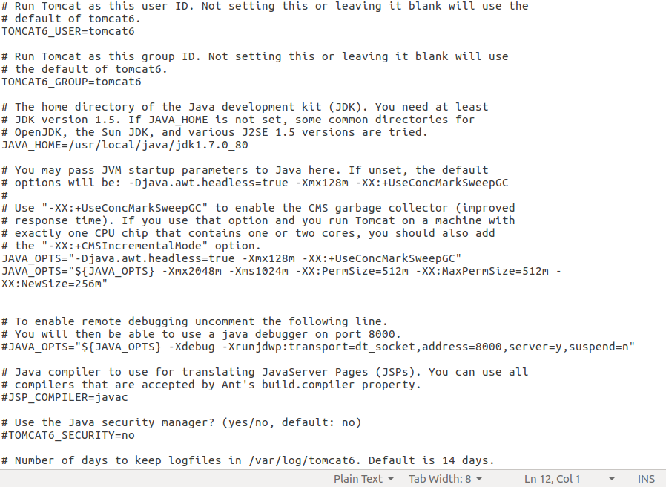



**2. Install the OpenMRS web application (openmrs.war)**

Download the openmrs war file [here](https://drive.google.com/file/d/1cZTrFxW8wmwPQ3HlvrGGhE_qSsghaJpa/view?usp=sharing)

• Copy the file from the webapp folder in the migration package folder to home:

**sudo cp openmrs.war /var/lib/tomcat6/webapps**

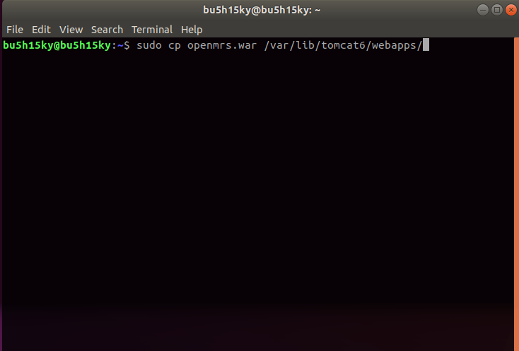

• Change permission of the openmrs.war file.

**sudo chmod 755 openmrs.war**

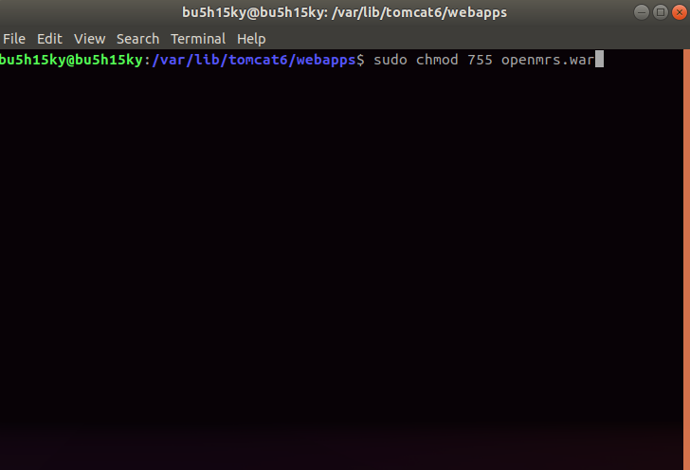

• Restart Tomcat:

**sudo service tomcat6 restart**

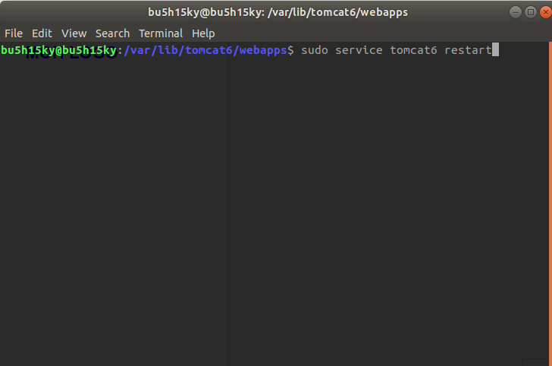

• Create the directory:

**sudo mkdir /usr/share/tomcat6/.OpenMRS**

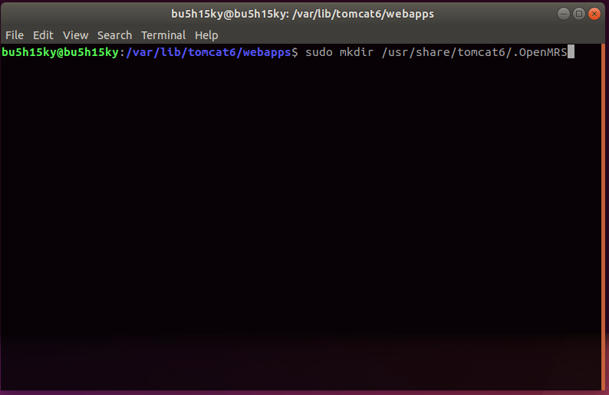

● Change the owner and group of the .OpenMRS directory to tomcat6:

**sudo chown tomcat6:tomcat6 /usr/share/tomcat6/.OpenMRS**

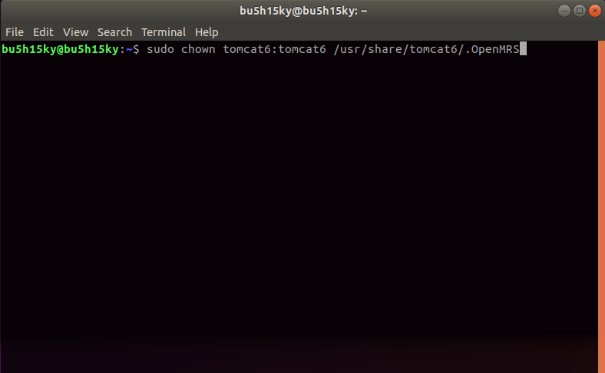

● Grant access rights to the .OpenMRS directory:

**sudo chmod 755 -R /usr/share/tomcat6/.OpenMRS**

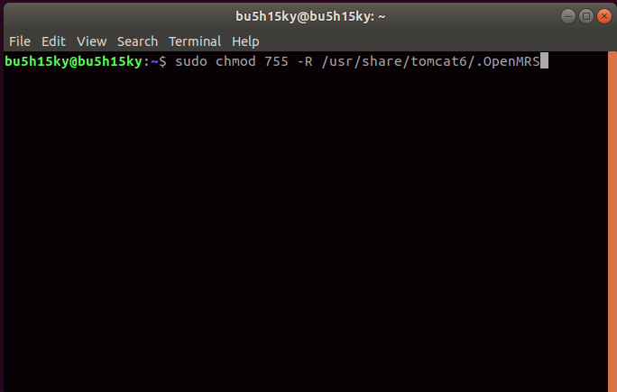

**4. Install KenyaEMR OpenMRS modules**

Obtain the appropriate versions of KenyaEMR OpenMRS modules [here.](https://drive.google.com/drive/folders/1a2uN-iJisfJHEfJBDBlHkMkfw9KjuCoF?usp=sharing)

● Copy all of them into the /usr/share/tomcat6/.OpenMRS/modules directory.

**sudo cp –R modules/ /usr/share/tomcat6/.OpenMRS/**

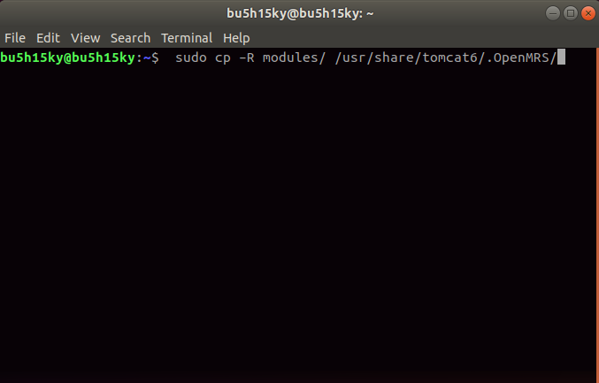

* Change ownership of the modules;

**sudo chown tomcat6:tomcat6 *.omod**

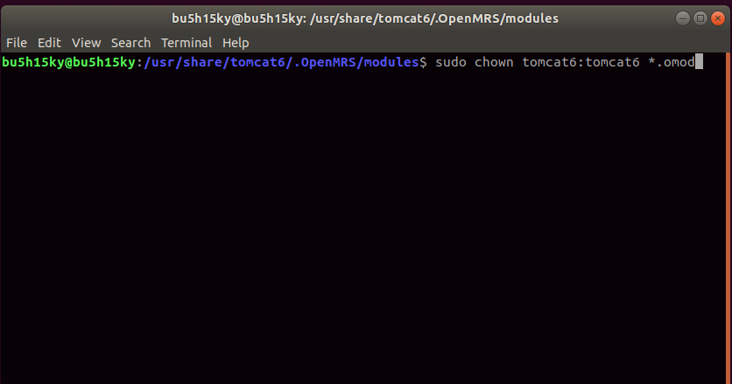

**•** Give the modules write permission;

**sudo chmod +r *.omod**

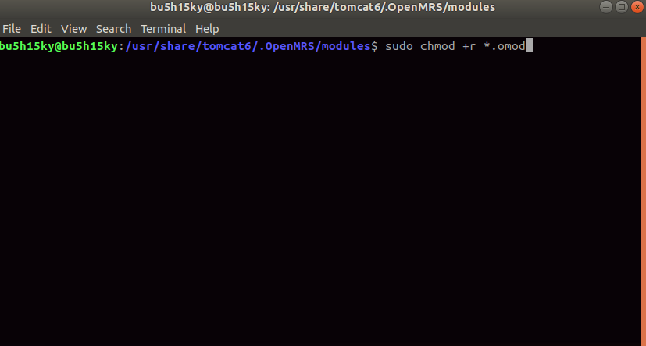

• Open your web browser and navigate to the URL **http://localhost:8080/openmrs**

To launch OpenMRS.For this first time the application will launch an installer.

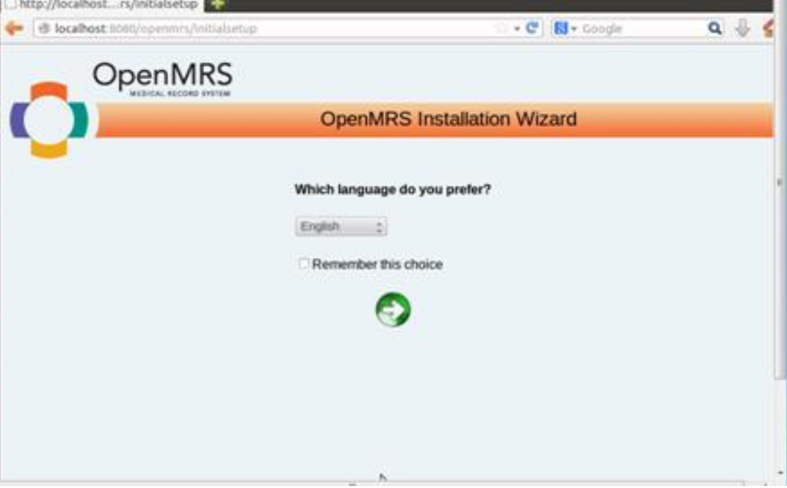

**●** Run through the installer Wizard choosing to install a fresh copy of the database when prompted. This will require that you supply the MySQL root password. When prompted to enter a password for the application superuser account, be sure to choose a strong password.

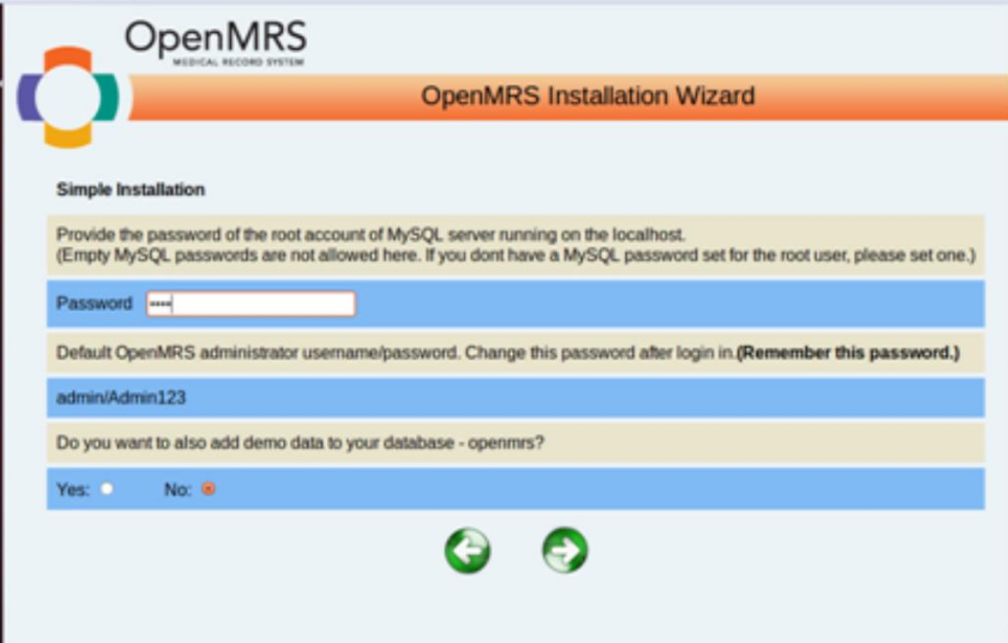

● Upon completion, you’ll see an error displayed on the browser because of an

outdated version of concept dictionary currently running.

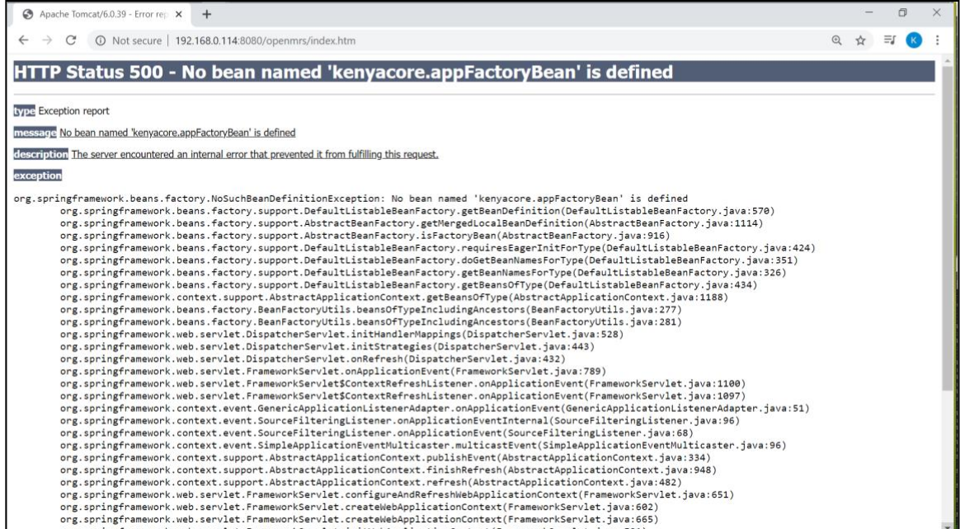

● Restore blank openmrs database to update the database

schema with the necessary database structure and concept dictionary

Copy the blank openmrs database to Home

Log into mysql;

**mysql -u root -p;**

enter mysql password when prompted

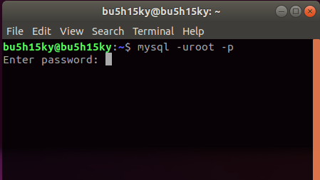

Use openmrs database;

**use openmrs;**

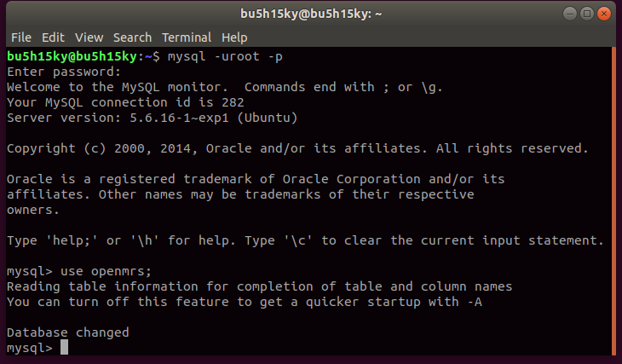

Source the blank database;

**source /home/bu5h15ky/bu5h15ky/blank_openmrs_17.1.0.sql;**

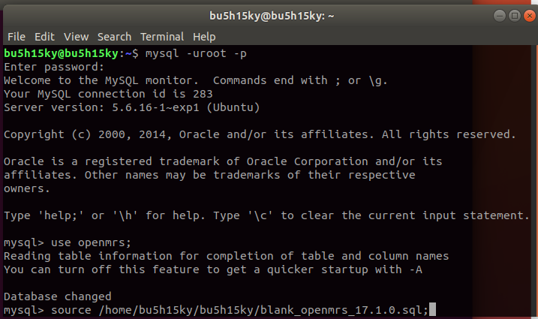

When the database restore is complete you will see the screen below

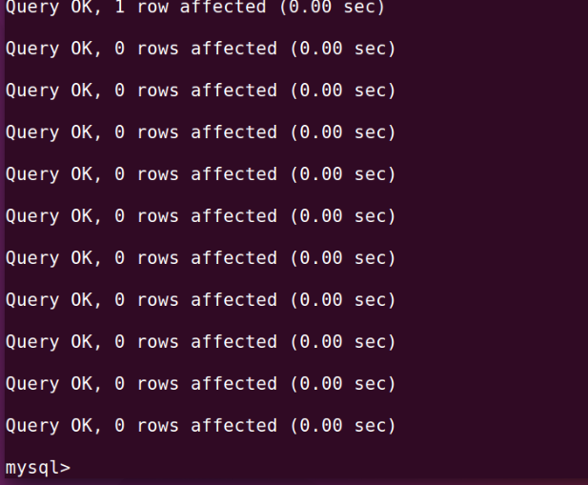

• Grant privileges to openmrs user

**grant all privileges on *.* to ‘openmrs_user’@’localhost’;**

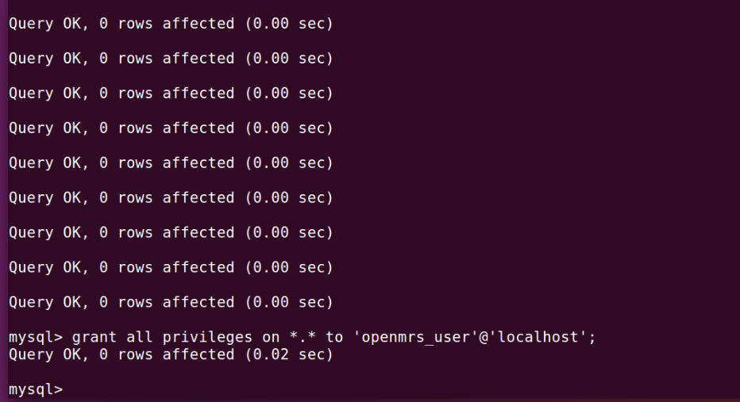

• Delete from liquibase

**delete from liquibasechangelog where id like ‘kenyaemrChart%’;**

Then exit mysql

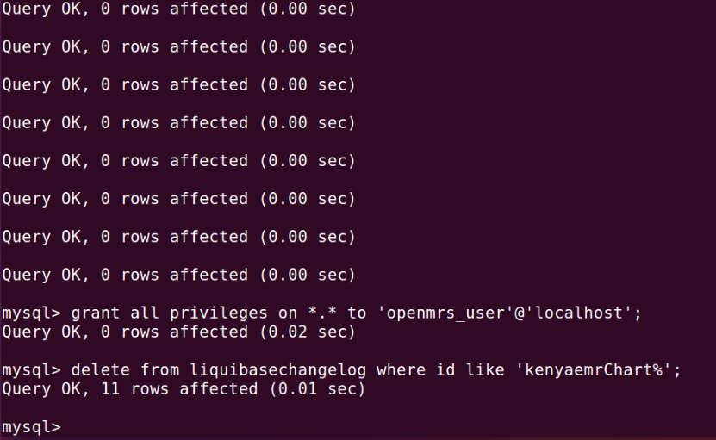

• Restart tomcat

**sudo service tomcat6 restart**

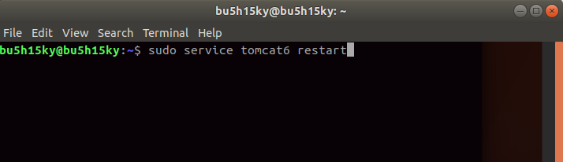

**6. Set up backup scripts and cron jobs**

Obtain the correct version of openmrs-backup-tools directory containing backup scripts and settings files.

● Copy the openmrs-backup-tools directory into the /usr/backups directory.

Enter password when prompted

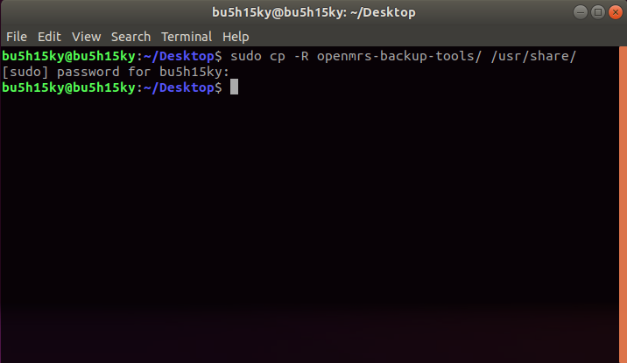

Change the ownership of the openmrs-backup-tools from root to the current user i.e.

**cd /var/backups/openmrs-backup-tools**

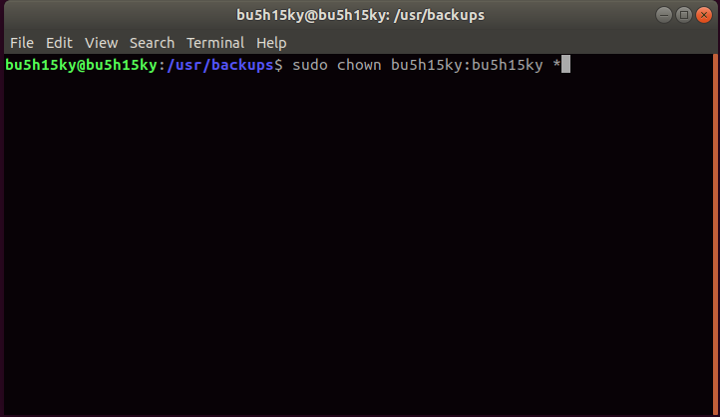

• Create the backup directory:

**sudo mkdir /var/backups/KenyaEMR**

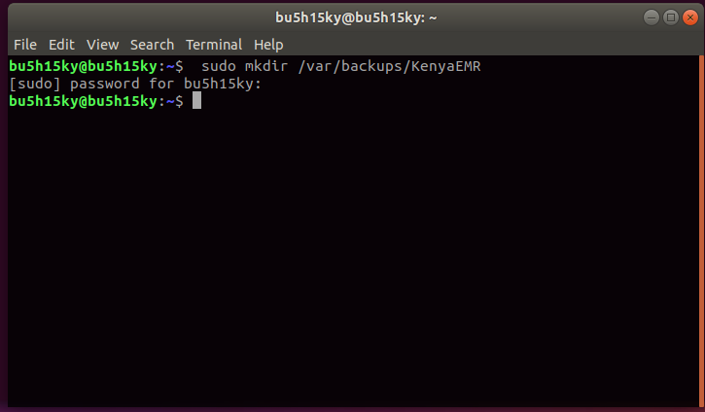

Change the ownership of the KenyaEMR from root to the current user i.e.

**sudo chown bu5h15ky:bu5h15ky /var/backups/KenyaEMR/**

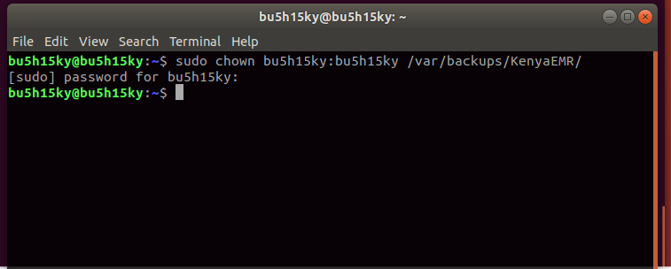

● Create a cron job to run the backup script on a daily basis by running

**crontab -e and select option 2. /bin/nano**

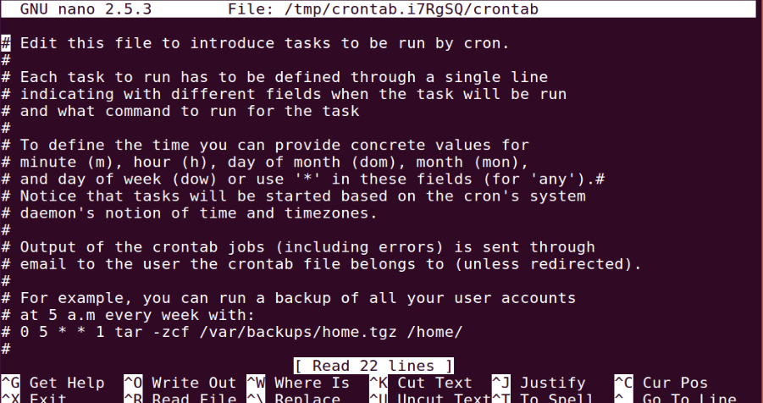

● Add the line in the text file that opens;

**00 11,16 * * * /usr/share/openmrs-backup-tools/openmrs_backup.sh.**

This will run a daily backup at 1100HRS and 1600HRS everyday

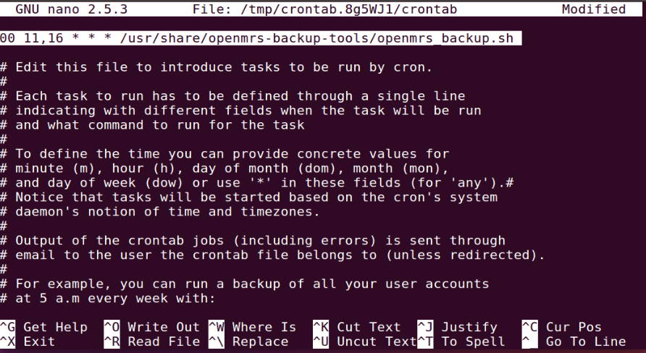

Then press Ctrl+x and press y and enter to save.

**7. Restart Tomcat:**

**sudo service tomcat6 restart**

**8. Open your web browser and navigate to the URL localhost:8080/openmrs to launch KenyaEMR.**

The application will take some time to launch this first time because it will first

install KenyaEMR metadata. At the end of the metadata installation process, the application will open and provide you with an interface to enter facility details.